**Project Proposal[1] :** *GotoGre MRM*

**Solution Direction**

*Description of chosen solution direction, including a brief description of any alternatives and why they were discarded. Present the alternatives that have been discarded in a table. Provide the analysis and rationale for choosing the selected solution direction over the alternatives. The KoST analysis should help.*

Currently I’m going with the solution direction of the software being a desktop only application instead of going via Web-based direction. That’s mainly because it seems to be a small store (only in hawthorn without the mention of any branches) and thus having local software will be enough to meet their demands.

Furthermore, it will also reduce security risk as it won’t be running on any network other than their local one and thus no chance of being attacked remotely by malware or hacker. Also, it will have the advantage of easy maintenance and backup as everything is local and so will not suffer in terms of duplication and discrepancy of data (which is a common issue in systems exposed to remote access).

Last but not the least, it will also be cheaper and faster to develop such a system, when compared to making a web based application, which in turn will ensure less loss of time and resources for the company wanting the software.

The KoST of this application is the following:

**Knowledge:**

**Problem domain:** Grocery shops, business operations, membership, IT software, warehouse stock, data

**Solution domain:** record management, sales recording, inventory control, data analysis, trend analysis, membership management, secure viewing for company

**Skills:** C# programming, use of mysql db server.

**Technology:** I have already done some similar project in both web base (Xamp, mysql, html, css, javascript, php) and desktop only application (C#, java, mysql) in my previous units’ assignments and thus know both the benefits and drawbacks surrounding each case.

*Also included is a high level design of the chosen solution direction showing each tier and how they interact with each other. Also included is a brief description of these components, their roles and responsibilities.*

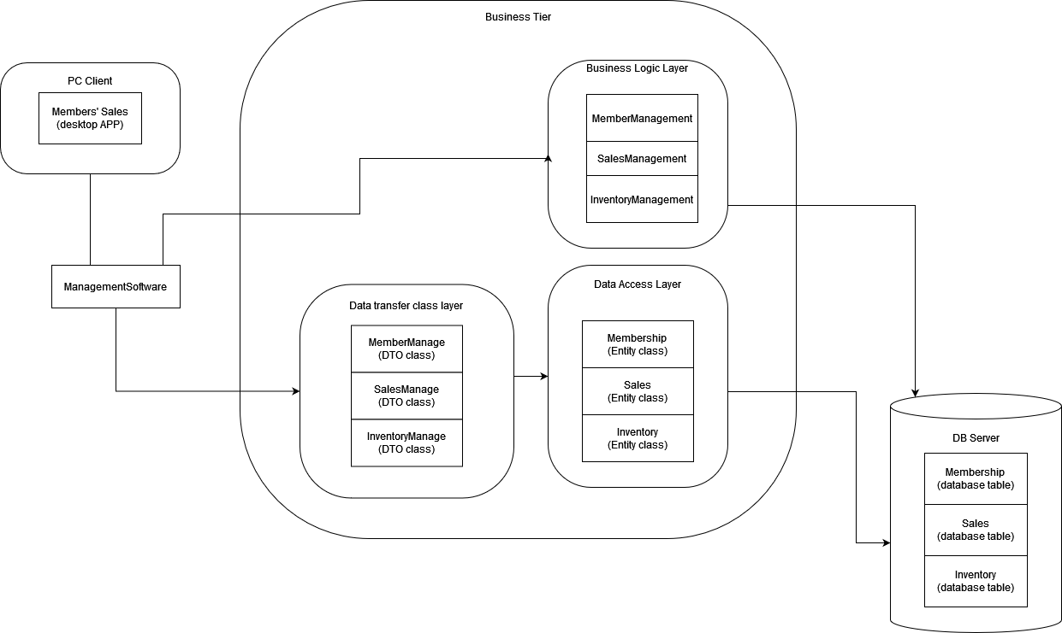

The PC client is the view that will be seen by the user. It will need relay the instruction/ commands given to it by the user, to the management software, which will in turn pass the commands to their relevant DTO classes, which will in turn frame the command and order the entities in the data access layer. These entities will then pass on the command to the db server which will make the change to the individual table’s data.

At the same time, the management software will also update the membership, sales and inventory management data stored in the business logic layer, which it will display back to the pc client through itself.

1. This document is by no means a “full project proposal”. It has been simplified and customized for the purposes of SWE30010 teaching. The full project proposal includes many other sections which have not been discussed during the first few weeks of SWE30010 teaching.